CHAPTER 3

MEASUREMENT OF EXCITON TRANSPORT IN DYE-DOPED AND BLENDED CONJUGATED POLYMER NANOPARTICLES

Reprinted (adapted) with permission from Groff, L. C., Wang, X. and McNeill, J. D. *J. Phys. Chem. C* **2013**, 117, 25748-25755, and Wang, X., Groff, L. C., and McNeill J. D. *J. Phys. Chem. C* **2014**, 118, 25731-25739. Copyright 2013, 2014 American Chemical Society.

**3.1 Introduction**

In recent years, there has been a great deal of interest in conjugated polymers, largely due to their application as the active materials in flexible, low-cost, highly efficient photovoltaic{Dennler, 2005 #1261} and light-emitting devices.{Yim, 2008 #1303} Conjugated polymer nanoparticles (CPNs) are of interest for use in biological imaging, given their high fluorescence brightness, extraordinary two-photon fluorescence cross-sections, and excellent photostability.{Wu, 2007 #1302}{Yu, 2009 #1304}{Wu, 2009 #1298}{Wu, 2008 #1299}{Wu, 2010 #1301}{Wu, 2013 #1300}{Koner, 2013 #1276} It is increasingly clear that further development of applications requires additional understanding of the complex photophysics and photochemistry of conjugated polymers, as well as their dependence on polymer structure and processing conditions. In organic semiconductors, the principal neutral electronic excitation of interest is typically the Frenkel-type singlet exciton.{Emelianova, 2010 #1265}{Kasha, 1965 #1273} Energy transfer between sites or chromophores occurs via multiple processes, including incoherent, diffusion-like processes,{Lunt, 2009 #1279}{Gammill, 1974 #1266}{Powell, 1969 #1287} dispersive transport,{Athanasopoulos, 2013 #1256} and in some cases, via ultrafast, long range coherent transport.{Scholes, 2006 #1288} In the exciton diffusion picture, each polymer chain is considered to consist of several more or less independent chromophores or exciton sites, and excitations transfer from one site to other nearby sites via transition dipole-mediated Förster transfer.{Burkalov, 2005 #1258} Multiple excitation transfer events typically occur during the excited state lifetime, resulting in a random walk-like process characterized by a diffusion constant or length. A large exciton diffusion length is required for optimum photovoltaic device efficiency (for some device types), since excitons must travel to the heterojunction to undergo charge separation. While the exciton diffusion length in high purity, crystalline inorganic semiconductors can reach several microns,{Gregg, 1997 #1267} it is typically much shorter for organic semiconductors. For example, measured exciton diffusion lengths for single crystals of anthracene range from ~30 nm to 60 nm,{Donati, 1978 #1263}{Mulder, 1967 #1285}{Simpson, 1957 #1290} and diffusion lengths of under 15 nm are typically reported for conjugated polymers.{Lyons, 2005 #1280}{Wu, 2008 #1297}{Tousek, 2012 #1294} Interacting chromophores can also give rise to aggregate species such as dimers, H- and J-aggregates, excimers, and exciplexes.{Jelly, 1936 #1271}{Hayer, 2012 #1268} Energy transfer can also occur to these and other species such as excess charges (polarons),{McNeill, 2002 #1282} defects introduced during polymer synthesis or processing,{Hintschich, 2003 #1269} or dopant species such as dyes and other polymers.{Wu, 2008 #1297;Wu, 2006 #1296} These processes can significantly reduce the observed exciton diffusion length. Various experimental methods have been developed for characterizing exciton diffusion, including photoluminescence quenching in layered structures,{Lunt, 2009 #1279;Hofmann, 2012 #1270} confocal fluorescence microscopy,{Kelbauskas, 2003 #1274} near-field fluorescence microscopy,{McNeill, 2000 #1284;Adams, 1999 #1255;Credo, 2001 #1260} time-resolved fluorescence of dye-doped films, crystals, or nanoparticles,{Powell, 1969 #1287;Lyons, 2005 #1280;Wu, 2008 #1297;Marciniak, 2012 #1281} and single particle imaging.{Bolinger, 2011 #1257},{Yu, 2012 #1305} Different assumptions are involved in the various methods, each contributing to different types of systematic error or bias, leading to a wide range of reported exciton diffusion lengths, as discussed by Forrest *et al*.{Lunt, 2009 #1279}

Here, we examine some processes relevant to the determination of exciton diffusion constants in dye-doped conjugated polymer nanoparticles by way of time-resolved fluorescence spectroscopy. In particular, we examine the effects of quenching by defects on the observed quenching efficiencies and excited state dynamics. While quenching by defects{Hintschich, 2003 #1269} and hole polarons{Yu, 2012 #1305} has been observed, quenching by defects is rarely quantified in studies of exciton transport dynamics in conjugated polymers, perhaps since it is preferable to minimize defects by employing proper technique. However, in some cases defects can be difficult to avoid entirely, or there may be quenching by intrinsic species such as aggregates, exciplexes, or photogenerated polarons. Furthermore, the combination of energy transfer and exciton diffusion can result in quenching radii as large as 10 nm.{McNeill, 2004 #1283} Thus, even very low concentrations of defects or other quenching species could give rise to significant quenching. Additionally, quenching by hole polarons is significant at a polaron density of 5x1017 cm-3,{McNeill, 2002 #1282;Deussen, 1995 #1262} which is often exceeded in functioning devices. We observe complex fluorescence decay dynamics consistent with significant quenching by defects in undoped nanoparticles of MEH-PPV and PFBT. Therefore, we develop a modified approach to determining exciton diffusion parameters that explicitly includes quenching by defects. By fitting the quenching efficiencies and complex fluorescence decay kinetics to an exciton diffusion model that explicitly includes quenching by defects, we obtain a corrected exciton diffusion length for nanoparticles of the polymer PFBT. Our results indicate typical analysis ignoring defects results in underestimation of *LD* by roughly a factor of 2. Analysis of the distribution of lifetimes provided additional confirmation of quenching by defects: The fluorescence decays of doped and undoped particles were fit to a stretched exponential function, yielding a stretch parameter **, which typically varies between ~0.3, indicating a broad distribution of lifetimes, and ~1.0, indicating a very narrow distribution (a single lifetime). Fitting the dynamics of undoped particles yielded ** = 0.6, consistent with significant quenching by defects. Analysis of the radiative and non-radiative rates was also consistent with quenching by defects. Our results indicate that quenching by defects can lead to significant underestimation of the exciton diffusion length, particularly for highly mobile excitons, which are highly susceptible to quenching, even at very low densities of quenching species or defects. The results are also promising for applications requiring highly mobile excitons, such as photovoltaic devices, since improvements in exciton diffusion length by a factor of 2 or more are expected if quenching by defects can be substantially reduced.

**3.2 Doped Nanoparticle Preparation Details**

Dye doped and blended conjugated polymer nanoparticles were prepared using the method described in Chapter 2.2. The specific details pertaining to the doping procedure are given as follows. Varying amounts of the dopant perylene red solution were mixed with the PFBT solution to produce solution mixtures with a concentration of 20 ppm PFBT and dopant/host fractions of 0 to 2 wt% perylene red. The mixtures were sonicated very briefly (3-5 s) to ensure homogeneity. For blended nanoparticles, varying amounts of dopant polymer MEH-PPV solution were mixed with a solution of host polymer PFBT solution to produce mixture solutions with a total polymer concentration of 20 ppm and a ratio of MEH-PPV/PFBT ranging from 0% to 10 wt %. A 2 mL quantity of each solution mixture was added rapidly to 8 mL of deionized water under sonication for ~30 s at a sonication frequency of 40 kHz and room temperature.

**3.3 Characterization Methods**

Size distributions and morphologies of undoped and perylene red doped PFBT nanoparticles were determined by atomic force microscopy (AFM). Samples were prepared by functionalizing the surface of a freshly cleaned glass coverslip with 3-aminopropyl-trimethoxysilane in anhydrous ethanol, followed by dipping in a diluted nanoparticle suspension for 40 minutes, then removing the coverslip and allowing it to dry overnight in an enclosed environment. Surface topographies were measured on an Ambios Q250 multimode AFM in tapping mode. The mean diameter of the CPNs was measured at 8 ± 2 nm. All of the perylene red doped PFBT CPN samples showed no substantial changes in mean diameter, with a similar size distribution.

UV-Vis absorption spectra were collected on a Shimadzu UV2101PC scanning spectrophotometer using 1 cm quartz cuvettes. Fluorescence spectra were collected and fluorescence quantum yield was measured using a commercial fluorimeter (Quantamaster, Photon Technology International, Inc.) using 1 cm quartz cuvettes. The UV-Vis spectra showed no variations from the undoped spectrum over the range of doping, and the absorbance of perylene red was well below the limit of detection of the instrument in the CPN suspensions. The fluorescence spectra of the CPN samples are given in Figure 3.3. The decreased lifetimes of the particles as compared to the polymer in good solvent are not likely to be due to J-aggregate formation, since little shift in the polymer absorption spectrum is observed upon nanoparticle formation (c.f. Fig. 3.1).

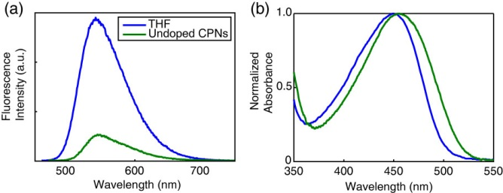

**Fig. 3.1.** (a) Fluorescence spectra and (b) normalized absorbance spectra of PFBT in THF (blue) and undoped PFBT CPNs (green).

The standard fluorescent dye fluorescein in 0.01 M sodium hydroxide was utilized to determine the fluorescence quantum yield of the PFBT CPN samples. 473 nm was selected as the excitation wavelength. The concentrations of the standard and nanoparticle suspensions were adjusted to yield an absorbance of ~0.05 at 473 nm. The absorbance, integrated fluorescence, and refractive indices of the sample and standard solutions were used in conjunction with the literature value of 0.92 for the quantum yield of fluorescein in 0.01 M sodium hydroxide to calculate the fluorescence quantum yield of the nanoparticle suspensions.{Weber, 1957 #47} The results of the quantum yield measurements are given in Figure 3.3 (c.f. Section 3.4). A Förster radius of 3 nm for the PFBT/perylene red donor/acceptor pair was calculated utilizing the absorption spectrum of perylene red in THF and the emission spectrum of undoped PFBT CPNs using standard methods,{Lakowicz, 2006 #1277} correcting for the polymer refractive index and assuming an orientation factor of , which is the standard result for dynamic reorientation of transition dipoles.

Fluorescence lifetimes were measured in air using the TCSPC method described in Chapter 2, with the instrument running in forward mode. Nanoparticle fluorescence was collected perpendicular to the excitation source after passing through a 460 nm long pass filter for the undoped nanoparticles. An additional 540 ±10 nm band pass filter was added for the doped samples in order to filter out the emission from perylene red. The excitation pulse was attenuated to maintain a valid start/stop event count rate of ~6 kHz. Several TCSPC kinetics traces were obtained for each sample. Data was acquired until roughly 103-104 photons had been collected. Typical signal-to-noise ratios were above 50:1 for the samples and 100:1 for the IRF.

**3.4 Initial characterization of dye-doped PFBT CPNs.**

Doping of conjugated polymer nanoparticles (CPNs) with dyes is being pursued as a strategy for improving their brightness and photostability while red-shifting their fluorescence, and as a way to investigate exciton diffusion in conjugated polymers. PFBT was selected as the host polymer owing to its excellent photostability and high fluorescence quantum yield, as well as its broad fluorescence spectrum, which facilitates energy transfer to dyes.{Wu, 2008 #1299} Perylene red was selected as the dye dopant for this system due to the excellent spectral overlap with the emission spectrum of PFBT and its high fluorescence quantum yield (0.96 in chloroform).{Brouwer, 2011 #1311;Seybold, 1989 #1312} Perylene red-doped PFBT CPNs were prepared via a nano-precipitation method described previously.{Szymanski, 2005 #1291} Samples were filtered through a 0.1 µm membrane filter and characterized via UV-Vis and fluorescence spectroscopy. Size distributions were determined via particle height analysis of representative AFM images (c.f. Fig 3.2). The AFM images are consistent with spherical nanoparticles, as is expected for glassy polymers in this size range, based on surface free energy considerations. Terentjev et al. previously reported spherical morphology for particles of PFBT roughly in this size range.{Yang, 2005 #1306}

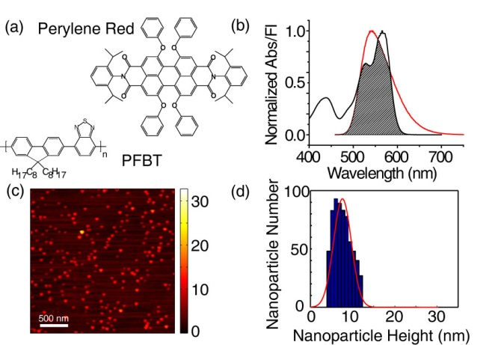

**Fig 3.2.**  (a) Structures of perylene red and PFBT. (b) Normalized perylene red absorbance (black line) and PFBT fluorescence (red line) in THF with spectral overlap region shaded. (c,d) Representative AFM image of undoped PFBT CPNs and particle size histogram.

Energy transfer efficiency as high as 86% was observed at 2% doping, where the energy transfer efficiency is given by **, and *F, F0* are the host fluorescence intensity in the presence, absence of dopant, respectively (c.f. Fig 3.3). It was expected that most of the dye is incorporated into the nanoparticles owing to the hydrophobic character of the dye, based on previous results examining incorporation of dyes with similar solubility properties, using centrifugal concentration to examine dye incorporation and possible leaching.{Wu, 2008 #1297} Additionally, the lack of additional features in the UV-vis and fluorescence spectra that could be ascribed to free dye or dye aggregate in solution is evidence that the fraction of unincorporated dye is small (less than a few percent). Finally, the high energy transfer efficiency at low doping ratios provides additional confirmation that a high fraction of the dye molecules are incorporated in the nanoparticles. The intensity of acceptor emission in the doped samples increases as dopant is added up to 0.5% doping. Upon further doping, acceptor emission intensity decreases. We ascribe this to aggregation quenching of the acceptor as dye dimers form within the nanoparticle at higher doping levels. Aggregate formation could also explain the red shift of the acceptor emission observed at higher doping levels. Stern-Volmer analysis was performed using the quencher/donor molecular fraction *f* = *ndye*/*npoly* as the unit of concentration, in order to obtain *KSV* in terms of the number of polymer molecules quenched per perylene red molecule. The analysis yields a quenching constant of 37 per dye molecule, indicating that roughly 37 PFBT molecules are quenched per dye molecule. From this result, an effective dye quenching radius of 5.3 nm is obtained, which is significantly larger than the calculated Förster radius, providing initial indication of exciton diffusion.

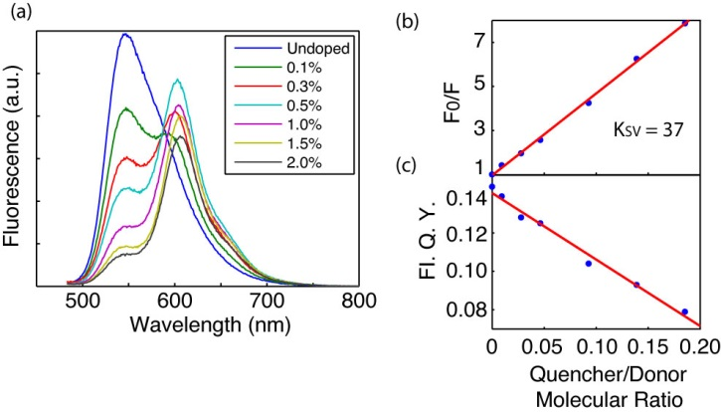

**Fig 3.3.** (a) Fluorescence spectra of perylene red doped PFBT CPNs at various doping ratios. (b) Stern-Volmer quenching plot. (c) Total fluorescence quantum yield vs. quencher-donor molecular ratio.

The quantum yield of undoped PFBT CPNs was measured to be 0.14, consistent with prior measurements.{Wu, 2008 #1299}{Tian, 2010 #1292}{Tian, 2013 #1293} The total fluorescence quantum yield of the doped samples decreases monotonically with increasing dopant concentration, indicating that doping with this dye does not increase CPN brightness as initially hoped (c.f. Fig 3.3). However, at moderate doping levels (0.5%-1%), the decrease in fluorescence quantum yield is minimal, while the energy transfer efficiency is high, thus doping with perylene red can be used to red-shift the fluorescence while maintaining high levels of brightness. In microscopic imaging experiments, signal levels and contrast are affected by several phenomena and factors related to the spectroscopy of the dyes and the experimental setup.{Ntziachristos, 2006 #1286} A key issue is autofluorescence from the sample and from the various optical materials. Autofluorescence typically peaks a few nm to the red of the excitation wavelength, with a long red tail. Thus, for typical dyes with small Stokes shifts, selection of filters involves a compromise between efficient collection of the emission of interest and rejection of autofluorescence. The PFBT nanoparticles doped with perylene red exhibit a large red-shift in the emission, which is advantageous for efficient collection of fluorescence and rejection of autofluorescence.

The effect of quenching by molecular oxygen on the quantum yield of the undoped PFBT CPN samples was assessed by purging the sample with nitrogen in the dark for 45 minutes prior to measurement. The quantum yield in air was measured to be 0.097, and 0.100 in nitrogen. The differences in quantum yield for the sample in air compared to the data in Figure 3.3 are not statistically significant, indicating negligible fluorescence quenching by oxygen.

**3.5 Picosecond time-resolved fluorescence spectroscopy**

Time-correlated single photon counting (TCSPC) was employed to determine the lifetimes of the excited state in doped and undoped nanoparticles of PFBT, and for the polymer dissolved in THF. The decay trace was fit by a least-squares minimization procedure involving convolution of a trial decay function with the instrument response function. The trial functions are (single) exponential, bi-exponential, and the stretched exponential or Kohlrausch-Williams-Watts (KWW) function,

. (1)

The stretch-parameter ** acts as a measure of lifetime heterogeneity, ranging between ~0.3 and 1, where lower values indicate a broad distribution of lifetimes while ** = 1 corresponds to a single lifetime.{Chen, 2003 #1259}The fluorescence decay of PFBT in THF was adequately fit by a single exponential, while the decays of undoped nanoparticles and lightly to moderately-doped particles (0.1%-1.0%) exhibited complex decay kinetics that fit well to both bi-exponential and stretched exponential (KWW) functions. While single exponential fits converged for all samples, bi-exponential and KWW fits did not converge for 1.5% and 2% doping due to low signal levels and short lifetimes relative to the width of the instrument response function. Results show a clear decreasing trend in lifetimes as the doping ratio is increased, with perhaps a slight decreasing trend in ** (c.f. Fig 3.4), though it is not clear that the decrease is statistically significant. In any case, the ** values indicate a broad distribution of exciton lifetimes for the nanoparticles, consistent with energy transfer in dense multichromophoric systems,{Wu, 2008 #1297} while the polymer in THF yielded ** values near unity, suggesting little energy transfer. Overall, the weighted average lifetimes and ** values obtained from the fits are consistent with the physical picture of exciton diffusion and energy transfer, i.e., dynamic quenching due to energy transfer, which will be discussed in more detail below.

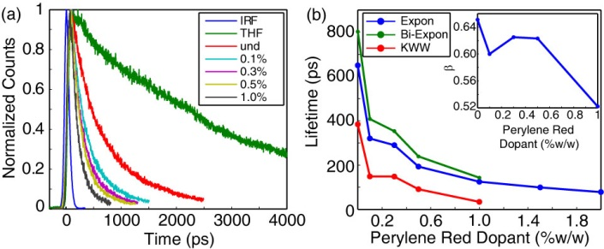

**Fig 3.4.** (a) Normalized fluorescence lifetime decay traces for PFBT in THF and doped CPNs. (b) Single exponential (blue), bi-exponential weighted average (green), and KWW (red) lifetimes of perylene red doped CPNs. Inset: KWW heterogeneity parameter *ß* vs. perylene red dopant percent.

Fitting was performed using a set of custom MATLAB scripts. Briefly, the fitting procedure is as follows. The model function consisted of either a single exponential, a bi-exponential, or a KWW decay function. Conventional gradient-based nonlinear least squares minimization methods such as Levenberg-Marquardt often fail for multi-exponential fitting, so an alternative approach was employed. A random number generator was used to generate a series of guesses for the nonlinear parameters (including shifts in *t0*, since small shifts in timing can occur due to drift) over a selected range. Then, for each set of nonlinear guess parameters, the trial fit function is convolved with the instrument response function and the linear parameters (i.e., the exponential amplitudes) are determined by linear least-squares. The sum of the square of the residuals (square error) for the set of parameters is calculated and compared to the minimum square error obtained thus far. If the new value is lower, then the parameters and the square error are saved. After several thousand iterations, the set of parameters corresponding to the minimum square error is taken as the set of best-fit parameters. The soundness of the fit is tested by additional sets of iterations with both wider and narrower ranges for the guesses, and by visual inspection of the residuals. Additionally, the range of data included in the fitting analysis, as well as the degree of downsampling of the data were varied, and the effect on the resulting fit parameters was evaluated. The fitting results for several TCSPC kinetics traces for each sample were used to determine the mean and standard deviation of the parameter values. Typical standard deviations of better than 10% were obtained for the lifetime values.

The effect of quenching by molecular oxygen on the lifetime of the nanoparticle samples was also assessed by comparing the lifetime results obtained for samples exposed to air with those obtained from nitrogen-purged samples. The bi-exponential weighted average lifetimes of the undoped PFBT CPNs were measured to be 780 ps in air and 850 ps in nitrogen. This difference is not statistically significant, and is in agreement with the quantum yield measurements indicating minimal quenching by oxygen.

In addition to the lifetimes of the host polymer PFBT, the lifetimes of the acceptor perylene red were measured. The lifetime of perylene red in THF was measured to be 5.4 ns, which is consistent with the literature value.{Al-Kaysi, 2006 #2} The moderate to heavily doped samples of PFBT nanoparticles were selected due to the relatively low contribution to the emission signal by PFBT as well as to assess the effect of the observed self-quenching of perylene red on its lifetime in the nanoparticles. The lifetime of perylene red doped within the nanoparticles was found to be reduced to 3.1 ns, and follows a decreasing trend as doping increases. The reduction in lifetime indicates dynamic self-quenching.

|  |  |
| --- | --- |
| **Perylene Red %(w/w)** | **τexp (ns)** |
| **THF** | 5.4 |
| **1.0%** | 3.1 |
| **1.5%** | 2.9 |
| **2.0%** | 2.6 |
|  | |

Table 3.1. Fluorescence lifetimes of the energy acceptor fluorescent dye Perylene Red in THF and in dye-doped PFBT CPNs.

**3.6 Modeling Exciton Diffusion and Energy Transfer in Dye-Doped CPNs**

Exciton dynamics in doped conjugated polymers can be described as mobile excitons hopping from site to site in a random, diffusion-like process prior to decaying (both radiatively and non-radiatively) or undergoing energy transfer to a defect or dopant molecule.{Tvingstedt, 2010 #1295}{Simas, 2010 #1289}{Dykstra, 2009 #1264} In this picture, a key exciton transport parameter is the diffusion length, , where *n* is the dimensionality, *D* is the (1D) diffusion constant, and ** is the exciton lifetime. We previously developed a numerical random walk approach to modeling the combined effects of exciton diffusion and energy transfer in CPNs, which yielded values for energy transfer efficiency that were in agreement with experimental results for dye-doped CPNs.{Wu, 2008 #1297} This approach was also applied to modeling fluctuations in the fluorescence centroid of a single CPN due to polaron motion.{Yu, 2012 #1305} Here, we have modified the previous simulation code to provide kinetics information for comparison to the time-resolved fluorescence results. We have also modified our approach to explicitly account for quenching by defects. Neither coherent transport nor dispersive transport are explicitly included in the present approach.{Athanasopoulos, 2013 #1256}{Scholes, 2006 #1288} The simulation algorithm is described as follows. The simulation code was written as a set of MATLAB scripts. Dopant dyes and/or defects are distributed randomly within the nanoparticle, represented by a sphere. While a sphere is assumed, similar results are obtained assuming a cubic particle.{Yu, 2012 #1305;Bolinger, 2011 #1257} Here we define “defects” as any of a number of quenching species such as polarons, aggregate species, conformational defects, oxidized defects and synthetic defects, which are not deliberately introduced into the system, in contrast to the dye molecules, which are deliberately added in controlled amounts. In these simulations, dopant dyes are essentially treated as points within a continuum. However, the model may be adjusted to correct for finite dye volume effects (e.g. by adjusting the Förster radius). It is expected that the addition of an exclusion volume would have a minimal impact on the quenching dynamics and on the quenching efficiency, since the volume of the dye is less than 2% of the nanoparticle volume. Similarly, the dye volume is smaller than the quenching volume by a factor of 20 or more. Finally, we note that in previous simulations,{Wu, 2008 #1297} we employed a discrete lattice model, and found that the quenching efficiency obtained was not sensitive to the lattice spacing, for lattice spacing of 0.1 to 0.4 nm, which is consistent with the reasoning above. An initial population of excitons is also distributed randomly within the sphere. For each time step *t*, each exciton is propagated by adding to its position along each axis a Gaussian-distributed random number scaled so that *2=2Dt*, where *D* is the (1D) diffusion constant and *2* is the variance of the random number distribution (** = 0). A time step *t* of 1 ps was employed, and time steps of 0.2 ps, 0.5 ps, 2 ps, and 5 ps were also tested, to help ensure that the simulation results were not significantly affected by numerical rounding errors or using a step that is too large given the various rates and diffusion distances involved. At each step, the new positions are checked to ensure that the exciton remains within the sphere representing the particle, and the jump is reversed for excitons that are outside the sphere, thus ensuring that the excitons remain within the sphere. The energy transfer rate, for each exciton to each dopant or defect, is calculated based on the exciton-acceptor distances and the conventional Förster rate expression,

. (S.2)

The probability of decay or transfer for a given exciton during the time step Δ*t* is calculated by the expression

 (S.3)

where *k* is given by either , or *ket*, and compared to a random number to determine the exciton fate for that time step. The running total of excitons that have decayed via energy transfer is updated (for later use in determining the quenching efficiency), and the exciton population is updated (for later use in constructing a simulated kinetics trace), for each time step. The simulation continues until nearly all of the exciton population has decayed. The simulations are performed for many initial random configurations of acceptors and excitons, and the exciton population kinetics and energy transfer efficiencies are calculated from the simulation results.

We explicitly include exciton quenching by defects (which can include aggregates, polarons, excimers, synthetic defects, oxidized defects, etc.) as a key feature in our approach to modeling exciton diffusion and energy transfer in the nanoparticles. The explicit inclusion of quenching by defects is based on several observations. First, the fluorescence quantum yield and excited state lifetime of the nanoparticles is greatly reduced ( = 0.14,  = 800 ps) as compared to the polymer in a good solvent such as THF ( = 0.66,  = 3000 ps). The phenomenon of reduced lifetimes in the aggregated state is often observed in J-aggregates, and is typically described as due to coupling of the transition dipole moments that causes a large increase in the radiative rate.{Kometani, 2000 #1275} However, strong J-aggregate-type coupling is not likely to be responsible for the decrease in lifetime in the present case, since little shift in the absorption spectrum is observed upon nanoparticle formation (c.f. Fig. 3.1), indicating weak coupling. Next, the radiative rates of the polymer dissolved in THF and the nanoparticles suspended in water were determined as follows. For the nanoparticles, a fluorescence quantum yield (c.f. Fig. S1) of  = 0.14 and weighted average excited state lifetime of  = 800 ps was determined, while for the polymer dissolved in THF,  = 0.66,  = 3000 ps was determined. From this information and the quantum yield expression,

. (S.1)

a radiative rate value for the nanoparticles of 1.8x108 s-1 was determined, while for the polymer in THF, a radiative rate of 2.2x108 s-1 was determined. This does not correspond to typical J-aggregate behavior. Rather, the radiative rate typically increases for J-aggregates as compared to the unaggregated dye. Finally, the heterogeneity of the excited state lifetime of the nanoparticle is increased (** = 0.65) as compared to the free polymer in solution (** = 1.0), consistent with quenching by energy transfer to some type of defect species, which could include oxidized defects, synthetic defects, aggregate species, exciplexes, and/or hole polarons (cations). Evidence for the existence of photogenerated hole polarons in PFBT CPNs is given in previously published work.{Yu, 2012 #1305} Additional support for the hypothesis of dynamic quenching by defects is given by analysis of the excited state lifetime and quantum yield results, which are not consistent with static quenching. Finally, the defect-quenching hypothesis is also supported by the agreement between experimental results and the exciton diffusion-energy transfer simulations, discussed below.

In order to account for quenching by defects in the simulation, the defect density (expressed as dye equivalents per nanoparticle) has been added as a model parameter. Exciton diffusion simulations were carried out for a particle of radius 4 nm, to match the 8 nm diameter determined by AFM (c.f. Fig. 3.2), with the exciton diffusion length set at 12 nm, and the time step set to 1 ps. In order to simulate a given dye and/or defect density, first the Poisson distribution of dyes or defects per nanoparticle was calculated by , based on the average number of dyes or defects per nanoparticle, (e.g., if = 1.7 dyes per particle on average, the Poisson distribution is used to estimate what population fraction of particles has *n* = 0, 1, 2, or 3 dyes, and so on) and simulations were performed assuming various numbers of dyes per nanoparticle, determined from the weight ratios of perylene red dopant. Then the kinetics curves and energy transfer efficiencies were combined using Poisson statistics to produce a weighted average kinetics curve and energy transfer efficiency for the dopant density of interest. Initially, a Förster radius of 3 nm was calculated by

, (S.4)

using the refractive index of PFBT at the peak emission wavelength (~1.9),{Campoy-Quiles, 2005 #1310} the spectra of perylene red  and PFBT in THF , the quantum yield of PFBT in THF, and assuming a value of 2/3 for the orientation factor *2*.{Lakowicz, 2006 #1277} However, while the match to experimental lifetimes and *ß* values improved, the simulation results did not match experimental quenching efficiencies well. It is likely that local ordering of the polymer could result in a somewhat larger value of the orientation factor, or that other physical processes such as coherent transport could lead to a larger quenching radius.{Athanasopoulos, 2013 #1256}{Scholes, 2006 #1288} Thus, simulations were carried out using an increased *R0* of 4 nm. This improved the agreement with experimental quenching efficiencies. It is assumed that a combination of exciton diffusion and energy transfer in the aggregated state of the polymer are the principal causes of defect quenching in the nanoparticles. The single exponential decay kinetics and high quantum yield exhibited by the polymer in good solvent, assumed to be due to the open conformation of the polymer, as well as the reduction in quantum yield and complex decay kinetics exhibited in the aggregated state of the polymer supports this notion. In order to quantify the defect density per nanoparticle, the fluorescence quantum yields of PFBT in THF and undoped CPNs were utilized to first estimate the defect quenching efficiency  which yields a quenching efficiency of ~0.79. Exciton diffusion and energy transfer simulations were performed using the same model parameters as were used to model the dye-doped CPNs, varying the defect density until good agreement with the quenching efficiency, lifetime and *ß* of undoped CPNs was obtained, yielding a defect density of 2.3 defects per nanoparticle or 8.6x1018 defects per cubic centimeter of polymer.

The defect density was estimated by comparison of simulation results to experimental results as follows. It was assumed that quenching by defects occurs primarily via a combination of exciton diffusion and energy transfer, and thus quenching is greatly reduced for the polymer in good solvent, since exciton diffusion is essentially eliminated and energy transfer is greatly reduced when the polymer adopts an open conformation (due to the increased inter-chromophore distance), while the polymer in the collapsed, aggregated state possesses a relatively higher chromophore density, favoring both energy transfer and exciton diffusion. Indeed, prior work shows that even a single defect or dopant per CPN can result in substantial quenching.{Yu, 2012 #1305}{Wu, 2008 #1297} The assumption of relatively little quenching for the polymer in an open, unaggregated conformation is supported by the much higher fluorescence quantum yield and single-exponential decay kinetics observed for the polymer dissolved in THF (decay kinetics are typically complex when energy transfer over a range of distances occurs). Thus a comparison between the fluorescence quantum yield and kinetics for the polymer dissolved in good solvent versus for the polymer in the nanoparticle state yields information about the extent of quenching in the nanoparticle. In order to quantify the defect density per nanoparticle, the fluorescence quantum yields of PFBT in THF and undoped CPNs were utilized to first estimate the defect quenching efficiency  which yields a quenching efficiency of ~0.79. To estimate the defect density, we performed exciton diffusion and energy transfer simulations as described above, using the lifetime of the polymer in good solvent and assuming the same Förster radius as the dye and the same *LD* parameter used to model the dye-doped CPNs. The defect density was varied until good agreement with the experimental average lifetime, ** parameter, and fluorescence quantum yield of the undoped CPNs was obtained. The defect density corresponding to the best fit for the undoped nanoparticles varied depending on the *LD* parameter, but for *LD* = 12, (the global best-fit value, see below) an effective defect density of 2.3 dye equivalents per 8 nm dia. nanoparticle, or 8.6x1018 defects per cubic centimeter of polymer was obtained.

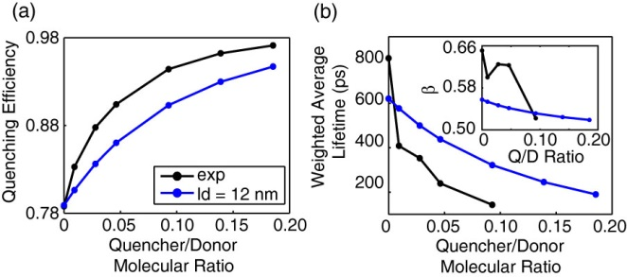

**Fig. 3.5.** Comparison of simulated (blue) and experimental (black) (a) quenching efficiency, (b) average lifetime, and KWW stretch parameter *ß* (inset) vs. quencher/donor molecular ratio.

To further test the model and assumptions, and to obtain the exciton diffusion length, simulations were also performed including doping with the perylene red dye, varying the exciton diffusion length to provide the best match to experimental quenching efficiencies and exciton decay kinetics. Based on the weight fraction of the dye, the average number of dyes per nanoparticle was calculated, and this was added to the number of defects determined previously. The quenching efficiencies and fluorescence decays obtained from the simulation are compared to experimental results in Fig. 3.5, for *LD* = 12 nm, with the density of dye represented as a ratio of the number of dyes to the number of polymer molecules (given the molecular weights of the polymer and dye, a molecular ratio of 0.10 corresponds to a weight fraction of 1.0% or a dye density of 6x1018 dyes per cubic centimeter of polymer). By utilizing the lifetime and quenching efficiency results for the nanoparticles at various doping levels as well as for the polymer in good solvent, we are able to probe the relative contributions of exciton diffusion, energy transfer, and quenching by defects on the exciton diffusion length. Simulations neglecting quenching by defects and Poisson statistics yield a good fit to experimental quenching efficiency; however, the fits to experimental lifetimes and ** are poor (c.f. Fig 3.6). By accounting for quenching by defects and Poisson statistics in the model, there is a trade-off in that the fit to experimental quenching efficiency is somewhat poorer, but the match to the lifetimes and *ß* is greatly improved. Nevertheless, the simulation results obtained including the Poisson distribution for defects and dyes fit reasonably well to all of the experimental results. The obtained exciton diffusion length of 12 nm is similar to that obtained for polyfluorene films by a different method.{Lyons, 2005 #1280}

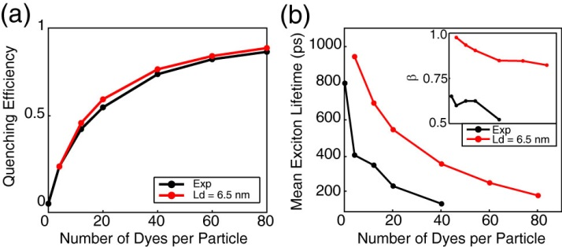

**Fig 3.6.** Exciton diffusion simulation results ignoring quenching by defects and Poisson statistics. (a) Simulated (red) and experimental (black) quenching efficiency, (b) mean exciton lifetimes, and *ß* (inset) as a function of dyes per nanoparticle for a particle radius of 12 nm.

The Stern-Volmer analysis yields a quenching radius of 5.3 nm for perylene red--significantly higher than the Förster radius *R0*, even if we make favorable assumptions regarding orientation, clearly indicating that exciton diffusion contributes significantly to the quenching efficiency of the dye. However, analysis of the quenching efficiencies alone does not clearly indicate the relative contributions of *LD* and *R0*: Results of exciton diffusion simulations (c.f. Fig 3.7) indicate that an increase in *either* *LD* or *R0* (or both) results in an increase in quenching efficiency. While there is no simple, exact analytical formula relating *LD* and *R0* to the *β* parameter, we found that *β* increases monotonically with increasing *LD*, (i.e., increasing *LD* results in a decrease in the amount of heterogeneity in energy transfer rates) while *β* decreases as *R0* increases. By including analysis of the *β* parameter, as well as quenching by defects, we obtained a significantly larger value for the Förster radius than that obtained using the typical assumption of *κ2* = 2/3, suggesting that this assumption may not be accurate for this system.{Wu, 2008 #1297} These results strongly suggest that a combined approach of measuring exciton decay kinetics, quenching efficiency, and modeling (in which quenching by defects is explicitly included) is necessary in order to disentangle the combined effects of exciton diffusion and energy transfer on exciton quenching efficiencies and dynamics.

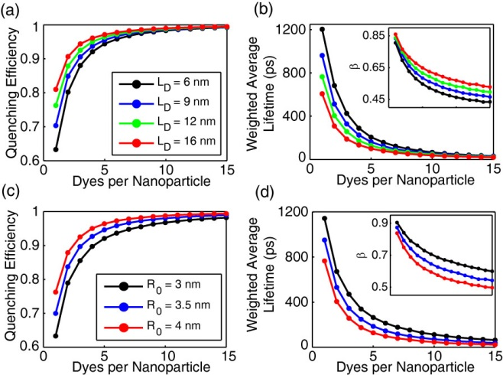

**Fig. 3.7.** Initial exciton diffusion simulations for a 4 nm particle radius. (a,b) Quenching efficiency, bi-exponential weighted average lifetime, and ** (inset) vs. dyes per nanoparticle for LD = 6 nm (black), 9 nm (blue), 12 nm (green), and 16 nm (red). (c,d) Quenching efficiency and bi-exponential weighted average lifetime, and *ß* (inset) vs. dyes per nanoparticle for R0 = 3 nm (black), 3.5 nm (blue), and 4 nm (red).

Another important issue is the effect of quenching by defects on the determined exciton diffusion parameters, particularly the diffusion length and calculated *R0*. By explicitly including quenching by defects in the simulation and analysis, we obtain an (intrinsic) exciton diffusion length (i.e., an exciton diffusion length for a hypothetical defect-free material). The intrinsic exciton diffusion length is 85% larger than the phenomenological diffusion length obtained from dye-quenching analysis without inclusion of defect quenching. This result has several implications. First, that for cases where conjugated polymers exhibit a large decrease in fluorescence quantum yield in the aggregated state (i.e., films and particles) relative to the polymer dissolved in a good solvent, this may indicate highly mobile excitons undergoing energy transfer to a small fraction of defects. Thus, somewhat paradoxically, a large value of *D* can result in a small observed value for the diffusion length, *which in many such cases is determined largely by the density of quenching defects rather than by the diffusion constant*. Second, the approach and results presented here suggest a general method for determining both the defect density and the effect of quenching by defects on the measured exciton diffusion length. Third, the low defect densities we obtained (much lower than 1 defect per polymer chain) and large exciton diffusion lengths determined in the absence of quenching lend qualitative support to the extraordinarily large exciton diffusion lengths reported in the single molecule studies of Barbara et al.{Bolinger, 2011 #1257} Additionally, the significantly larger exciton diffusion length obtained from the lifetime analysis is promising for applications requiring large exciton diffusion lengths, such as photovoltaic devices. Finally, while the nature of quenching defects varies from polymer to polymer, in the case of some PPV derivatives as well as polyfluorene derivatives, quenching defects appear to be partially oxidized polymer, or hole polarons.{Hintschich, 2003 #1269}{Tian, 2013 #1293} In the case of hole polarons, quenching by defects can sometimes be suppressed by addition of electron-donor species.{Tian, 2013 #1293} Thus the addition of such species could be helpful for applications requiring larger exciton diffusion lengths.

**3.7 Concluding Remarks on Dye-Doped CPNs**

PFBT CPNs doped with perylene red dye were found to exhibit efficient energy transfer from the polymer host to the dye. The excited state dynamics of the dye doped CPNs were studied by steady state and time-resolved fluorescence methods. The spectra are red-shifted significantly with only minor losses in fluorescence quantum yield, indicating that these nanoparticles provide bright, red emission, which is useful for some imaging and tracking applications. The lifetime of the donor exciton is reduced and the width of the distribution of exciton lifetimes was found to increase as the dopant concentration increases, as determined by time-resolved fluorescence. We interpret the kinetics results and the results of simulations as indicating substantial quenching by defects, which is amplified by exciton diffusion. The simulation parameters were adjusted until a reasonably good fit was obtained to the experimental results, including the quenching efficiency results, the average lifetimes, and the KWW stretch parameter. Based on the fitting results, an exciton diffusion length of 12 nm for PFBT CPNs was obtained, corresponding to a diffusion constant of 8.0x10-9 m2 s-1. The results provide some indication that quenching by defects or other quencher species is a significant but often overlooked issue in aggregated conjugated polymers, and the approach described here--combining steady-state and time-resolved spectra of the dissolved polymer and doped nanoparticles--is proposed as a more or less general method for quantifying both exciton transport and exciton quenching by defects in conjugated polymer materials. Additionally, our analysis suggests that for some conventional approaches to determining exciton diffusion lengths, the result may be largely determined by the defect density.

**3.8 PFBT/MEH-PPV Blended CPNs**

There have been extensive investigations of exciton dynamics in conjugated polymer systems, including thin films,{Haugeneder, 1999 #139}{List, 2000 #65}{Shaw, 2008 #66} solutions,{Hennebicq, 2005 #68}{Dias, 2006 #69} in a matrix,{Yu, 2000 #33}{Hooley, 2014 #64} and nanoparticles.{Hu, 2002 #61} Since the structure of polymer blends (bulk heterojunctions) used in photovoltaic devices is often complex, it is desirable to gain a more complete understanding of the electronic and photophysical processes in blended conjugated polymers in order to optimize the device characteristics, as well as how such processes can be modulated through their dependence on structure and processing conditions. It has been proposed to study photophysical processes in blended conjugated polymers in the nanoparticle phase, as an alternative to thin films,{Tenery, 2009 #48}{Hu, 2010 #47} since more control of various aspects of structure and interactions can be obtained by controlling particle size, and since single nanoparticle experiments can provide a unique window into nanoscale heterogeneity effects and processes such as polaron motion.{Yu, 2012 #54} Furthermore, CPNs have attracted much attention in a variety of applications, such as particle tracking,{Yu, 2009 #20} sensing,{Wu, 2009 #23;Chan, 2011 #24;Childress, 2012 #25} and cellular imaging,{Wu, 2008 #21;Wu, 2010 #22} because of their small particle size, high fluorescent brightness and excellent photostability.{Wu, 2013 #19}

Previously,{Wang, 2013 #9} we found that blended PFBT/MEH-PPV CPNs exhibit unusual optical properties. In addition to the expected highly red-shifted emission due to energy transfer, we found anomalous saturation behavior characterized by an extraordinarily low excitation saturation intensity and high saturated brightness, a rare combination of properties that is optimal for saturation-based imaging methods.{Bretschneider, 2007 #79} Additionally, bulk and single nanoparticle spectroscopic experiments indicate that the blended CPNs exhibit photoswitching, which could be useful for localization-based microscopy.{Patterson, 2010 #78} The experimental steady-state and time-resolved spectroscopy results are given elsewhere.{Wang, 2014 #212} The experimental decay kinetics and quenching efficiency results are analyzed here by comparing to a multiple energy transfer model in order to examine the physical picture of processes occurring in blended CPNs and in an attempt to obtain a clearer picture of the impact and relative importance of multiple energy transfer (energy transfer between donor chromophores) occurring within the donor (host) polymer, energy transfer between donor and acceptor, acceptor conformational effects (e.g., degree of phase separation), acceptor polydispersity, and particle size. Our analysis indicates that multiple energy transfer between donor chromophores greatly increases the effective quenching volume of the acceptor. Additionally, the high energy transfer efficiencies are consistent with a more or less open conformation of the acceptor chain, rather than a compact, phase segregated structure. The polydispersity of the acceptor polymer is found to play a role in the high degree of heterogeneity of energy transfer rates. In addition to providing results that could be useful for tailoring the properties of CPNs for imaging applications, these results could help provide insight into the factors affecting energy transport processes in devices containing conjugated polymer blends, such as in bulk heterojunction photovoltaic devices.

**3.9 Modeling Exciton Transport in Blended CPNs**

We have adapted the model detailed in Section 3.6 to simulate exciton diffusion in blended conjugated polymer nanoparticles. We included defect quenching by representing defects as nonfluorescent energy acceptors with a Förster radius of 4 nm, adjusting the level of defects until the kinetics and fluorescence quantum yield were in approximate agreement with experimental results for undoped PFBT CPNs, using the approach discussed above. Since the number of defects per CPN is likely to follow a Poisson distribution, the defect density was estimated by comparison of model calculations to the CPN fluorescence quantum yield and fluorescence decay kinetics as follows. First, the initial exciton diffusion simulation is performed by varying the dye (quencher) number per particle with lifetime of PFBT in THF (3400 ps), particle radius r = 11 nm (from AFM results), exciton diffusion length *LD* = 12 nm, Förster radius *R0* = 4 nm. The quenching efficiency and exciton decay kinetics for various numbers of dyes per particle are obtained from exciton diffusion simulations described above. The simulated quenching efficiency versus number of dyes per particle is shown in Figure 3.8(a). Second, the population of nanoparticles is described by an average defect density parameter (average number of defects per particle), with the fraction of particles containing a given number of defects given by the Poisson distribution. From the distribution weights and the simulation results, a weighted average quenching efficiency is obtained, and similarly, population-averaged decay kinetics traces are obtained and fit to a bi-exponential and KWW functions to obtain the average lifetime and ** parameter. The average defect density is varied until a good agreement with experimental data is obtained, yielding an average defect density of 20 dye equivalents per 22 nm diameter particle. At this average defect density, the simulated result for PFBT particle is *ηd* = 0.79, *τavg* = 750 ps, and *β* = 0.75. The quenching efficiency and averaged lifetime are consistent with the experimental data (*ηd* = 0.80, *τavg* = 770 ps). The slightly lower experimental KWW stretch parameter *β* (0.64) for the experimental data as compared to the simulated result (0.75) perhaps indicates an additional process or effect leading to broadening of the lifetime distribution.

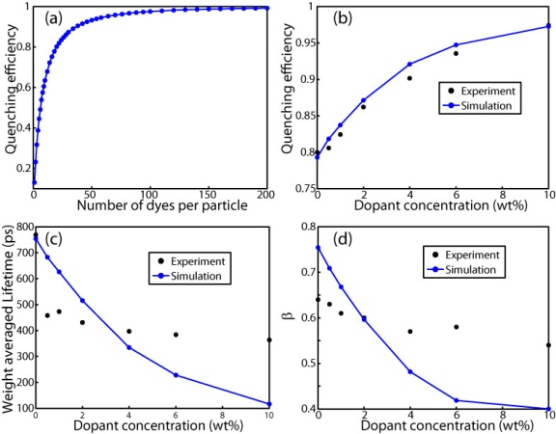

**Figure 3.8** (a) Quenching efficiency of initial exciton diffusion simulations; (b, c, d) Comparison of simulated (blue dot with line) and experimental (black dot) data: (b) quenching efficiency, (c) average lifetime, and (d) KWW stretch parameter *β*,vs. dopant concentration (wt%).

The quenching efficiency values of the blended CPNs given in Figure 3.8(b) are given by equation, $η=η_{d}+\left(1-η_{d}\right)(1-F/{F_{0})}$, where *F0* and *F* represent the nanoparticle fluorescence intensities of unblended and blended CPNs, respectively. The calculation of quenching efficiency of the polymer is obtained from the exciton diffusion and energy transfer results (Figure 3(a)) as follows. As stated above, the high quenching efficiency of MEH-PPV indicates that the molecule likely exhibits an open or extended conformation. Since the conformation or conformational distribution is not known, and for the sake of computational simplicity, we represent the extended MEH-PPV chain as isolated chromophores randomly distributed throughout the particle. This is a gross simplification that is likely to overestimate quenching efficiency, since a more realistic beads-on-a-string picture would result in correlation between chromophore positions (i.e., there will typically be 1-2 chromophores within ~1 nm of a given chromophore), resulting in overlap of quenching volumes, likely resulting in a reduced quenching efficiency. On the other hand, assuming a random distribution of chromophores places some in closer proximity than would a space-filling bead model, so there could be some cancellation of errors.

A likely more significant issue is the polydispersity of the acceptor polymer. Here we discuss how acceptor polydispersity is included in the model. Gel permeation chromatography (GPC) yields Mn = 47400, Mw = 206000, and a polydispersity index (PDI) of 4.3. For modeling purposes, we represent the polymer weight distribution as a mixture of four different polymer components with molecular weights of 3900, 10400, 104000, and 312000, and number (molecule) fractions for each component of 0.47, 0.26, 0.17 and 0.1. The molecular weight distribution of the mixture is Mn = 53400, Mw = 217000, and PDI = 4.1, close to the GPC results. The distribution of the various molecular weight polymer chains in the particles is calculated using the Poisson distribution (i.e., it is assumed that the dopant polymer chains are randomly distributed among particles) based on the weight fraction of MEH-PPV (per nanoparticle) and the population fractions for each molecular weight, using the expression $N_{i}={M_{NP}f}_{d}f_{i}/M_{i}$, where *Ni* is the number of chains of a given component *i*, *MNP* is the mass of nanoparticle, *fd* is the doping fraction, *fi* is the molecule fraction of component *i*, and *Mi* is the mass of component *i*. For a given nanoparticle containing a number of polymer chains of various molecular weights, the number of MEH-PPV chromophores is calculated based on the following reasoning. An MEH-PPV chromophore is composed of 4~8 repeat units.{Holzer, 2004 #42}{De Leener, 2009 #43}{Kohler, 2012 #44} If we assume that 5 repeat units is one chromophore (~1300 Daltons), then a straightforward calculation (based on the peak extinction coefficient MEH-PPV polymer mentioned earlier) yields a peak extinction coefficient per chromophore of ~4×105 M-1 cm-1. We treat the chromophore size as an adjustable simulation parameter, and used a value of 5 monomer units per chromophore in the simulations. For the sake of reducing calculation complexity, we assume that each chromophore is roughly equivalent to one perylene red molecule, which in terms of the simulation means that each chromophore is represented as a point acceptor with a Förster radius of 4 nm, which is the same as the Förster radius used to represent the defects. Thus the total number of energy acceptors in a nanoparticle is given as the sum of the number of defects and the number of MEH-PPV chromophores.

A statistical sample of CPNs, representing the distribution of defects and polymer chains is generated, and for each CPN, the total number of acceptors is calculated using the method described above. From the distribution, the population average quenching efficiencies and kinetics are calculated. The simulated population-averaged kinetics trace is fit to bi-exponential and KWW functions to obtain weighted average lifetimes, and KWW stretch parameter *β*, for each blending ratio, which are given in Figure 3.8(b-d). The agreement between the simulated quenching efficiency and the experimental results is good, while the lifetime and *β* simulated results agree reasonably well with the experimental results for much of the range of doping levels, with systematic deviations at the lower and higher doping levels. While the cause of the deviation cannot be determined conclusively, the somewhat poor agreement is not surprising given the number of simplifications and assumptions in the model. Even for the simpler case of dye-doped PFBT CPNs, the fit of lifetime and *β* was not particularly good.{Groff, 2013 #8} Possible causes or explanations are discussed below.

First, for the case of higher doping concentration, the short lifetime and small *β* represent an experimental difficulty since there are likely some significant short lifetime components in the decay trace that are not resolved with the TCSPC apparatus. For example, at 10% MEH-PPV doping, there is a significant ~3 ps lifetime component when fitting the first few points of simulated population kinetics to a single exponential decay function. This short-lived component is well below the ~80 ps experimental resolution. Short-lived components also contribute few photons to the kinetics trace, which can make them difficult to measure. Also complicating the determination of short-lived components is the fact that a small amount of scattered laser light or autofluorescence can overlap with the kinetic trace at early times.

Additional effects and processes that we have not included in the model could also affect the overall energy transfer rate and the width of the distribution of rates, such as heterogeneous or dispersive exciton transport caused by energetic heterogeneity{Barbara, 2005 #72} and particle-to-particle variations arising from the particle size distribution. Additionally, the acceptor chain conformation is not included in the current model. Furthermore, the current model is essentially a continuum model, and it is likely that a more granular model that explicitly includes individual donor and acceptor chromophores would yield a smaller distribution of donor-acceptor distances and thus a smaller distribution of energy transfer rates, which could improve agreement between the model and experiment. It is also possible that adjacent PFBT and MEH-PPV chromophores could result in mostly static quenching of the PFBT chromophore, which could explain the fact that the measured lifetimes appear to be less sensitive to doping concentration than predicted by the model, which assumes mostly dynamic quenching. Further development of the model for blended conjugated polymer nanoparticle is planned, including treating the polymer chain as dye/beads-on-a-string, and replacing the continuum approach with one that includes discrete donor and acceptor chromophores. Additional experiments using dopant polymers with a lower polydispersity index are planned and could also serve as a useful test of model assumptions and the effect of polydispersity on the distribution of energy transfer rates.

**3.10 Conclusions Regarding Blended CPN Dynamics**

Additional insight into the nature of energy transfer processes in blended conjugated polymers was obtained from picosecond fluorescence lifetime measurements and comparison to a multiple energy transfer model. Donor exciton lifetime reduction and lifetime distribution broadening with increase of doping were determined by picosecond fluorescence lifetime measurement, indicating a broad range of energy transfer rates. Agreement between experiment and model results for quenching efficiency is very good, and the differences between the simulated lifetime and *β* value and the time-resolved experimental data can be explained by some of the assumptions of the model (including the assumption that dynamic quenching predominates) and the limitations of the measurement. Our results indicate that both exciton diffusion and polydispersity of acceptor are the major factors in determining the quenching efficiency and energy transfer rates in blended conjugated polymer systems. These results help provide the basis for additional studies aimed at understanding the unusual fluorescence properties of PFBT/MEH-PPV nanoparticles including anomalous saturation behavior and photoswitching. Additionally, the results shed light on the complex exciton diffusion and energy transfer processes occurring in devices that include blended polymers, such as bulk heterojunction photovoltaic devices. Furthermore, the results indicate that quenching by defects (likely polarons) could limit performance of electro-optic devices, and that blending can, in some cases, improve performance, by providing a competitive energy transfer pathway. The results also clearly show that the conformation (e.g., extended/solvated versus collapsed chains forming nanoparticles) has a profound effect on key optical properties such as fluorescence quantum yield, likely due to increased energy transfer and exciton diffusion in the collapsed, nanoparticle conformation. The effect of the host polymer on polaron stability is also a likely factor. Finally, the results indicate the importance of measuring rates in complex systems using time-resolved methods, rather than adducing rates from steady-state measurements. For a simple system characterized by a single (dynamic) quenching rate constant *kq*, the quenching efficiency is given by a simple expression such as *Q = kq/ktot*, which can be rearranged to yield the rate constant, whereas for a complex system involving multiple rates and possibly static quenching, the relationship is complex, requiring a more direct measure of the rates involved. Indeed, while the (steady-state) quenching efficiencies are reproduced quite well by the model, the distribution of energy transfer rates obtained from the model are not in agreement with the time-resolved results, clearly indicating of the importance of time-resolved measurements in this case.